**Practical Appendix**

1. Start Visual Studio:
   1. Click Start→All Programs→Microsoft Visual Studio 201X→Microsoft Visual Studio 201X
2. Create a new project:
   1. Select File→New→Project
   2. Choose Visual C++→General for installed templates
   3. Select Empty Project
   4. Type in Practical1 for the name
   5. Click Browse and choose Desktop.

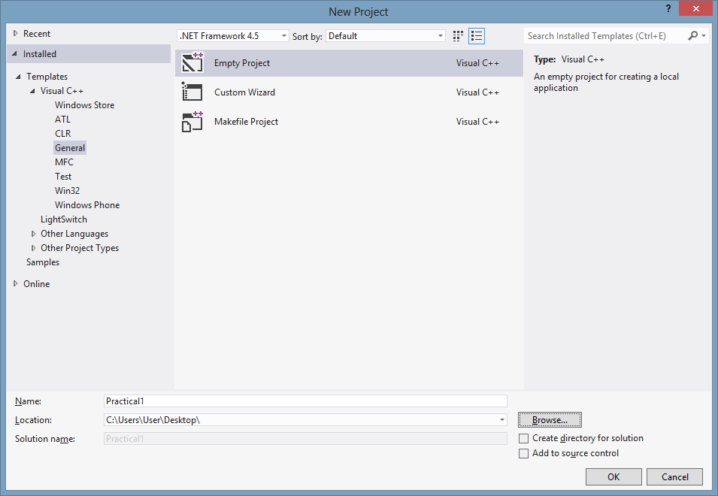

1. Right-click on the Project name in the Solution Explorer window. Select Properties.

Solution Explorer window

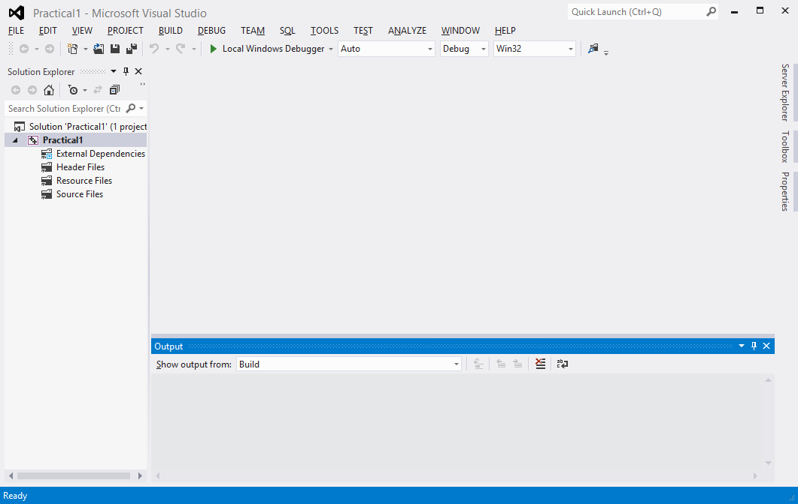

Project name

1. The Properties dialog window opens. Select Configuration Properties→Linker→System.

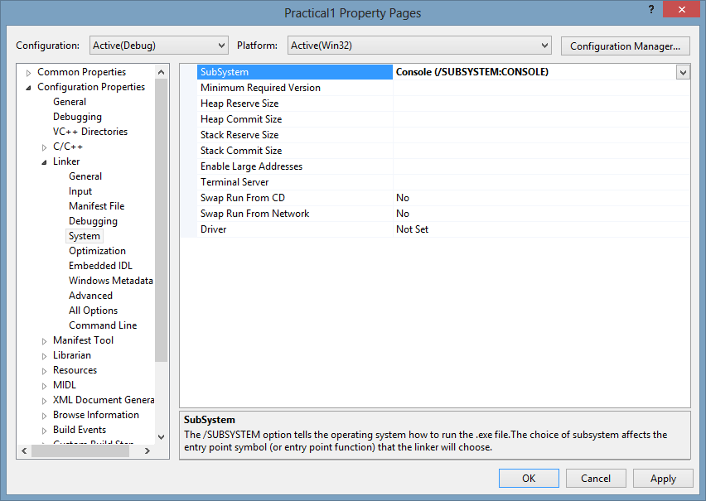

1. For SubSystem, choose Console (/SUBSYSTEM:CONSOLE).
2. Create a new program file (q1.cpp):
   1. Right-click Source Files folder in the Solution Explorer
   2. Select Add→New Item
   3. Select C++ File (.cpp)
   4. Type in q1 for the name.

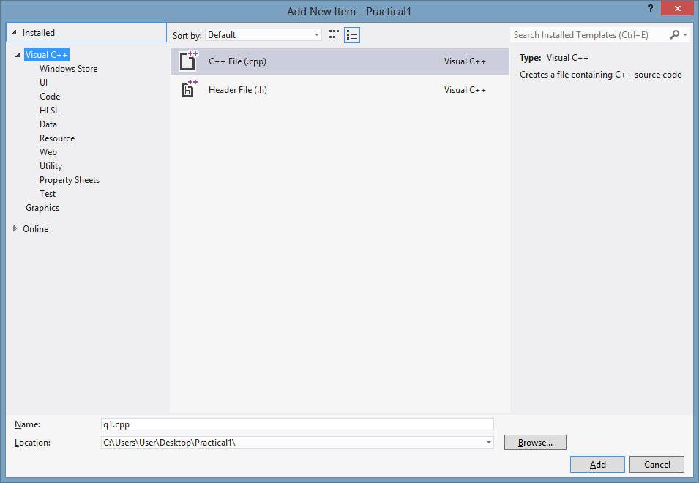

1. Type the program code into the Code Editor window.

Code Editor window

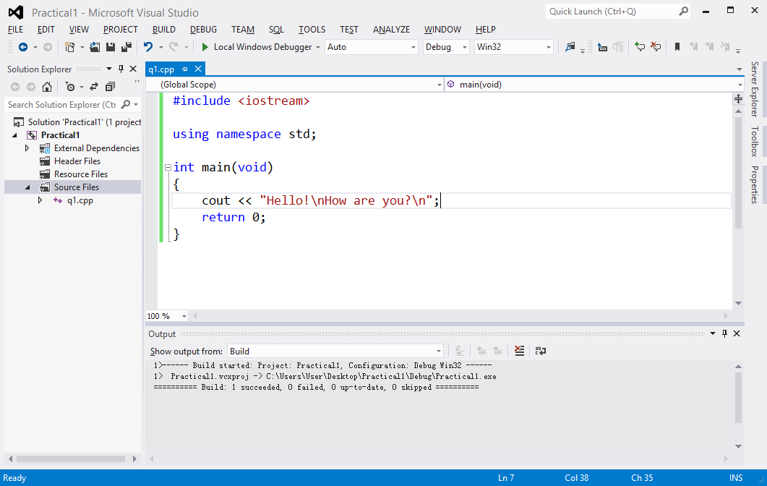

1. Compile the program:
   1. Select Build→Compile or press Ctrl+F7
   2. Make sure there are no error messages
   3. Ignore any warnings
2. Execute/run the program:
   1. Select Start→Start Without Debugging or press Ctrl+F5
   2. When the message “This project is out of date: Would you like to build it?” appears, click Yes.
3. Create another program file (q2.cpp):
   1. Right-click Source Files folder in the Solution Explorer
   2. Select Add→New Item
   3. Select C++ File (.cpp)
   4. Type in q2.cpp for the name.
4. Run the second program:
   1. In the Solution Explorer window, right-click the program file q1.cpp and select Properties.
   2. In the Property Pages dialog window, change “Excluded From Build” to “Yes”.

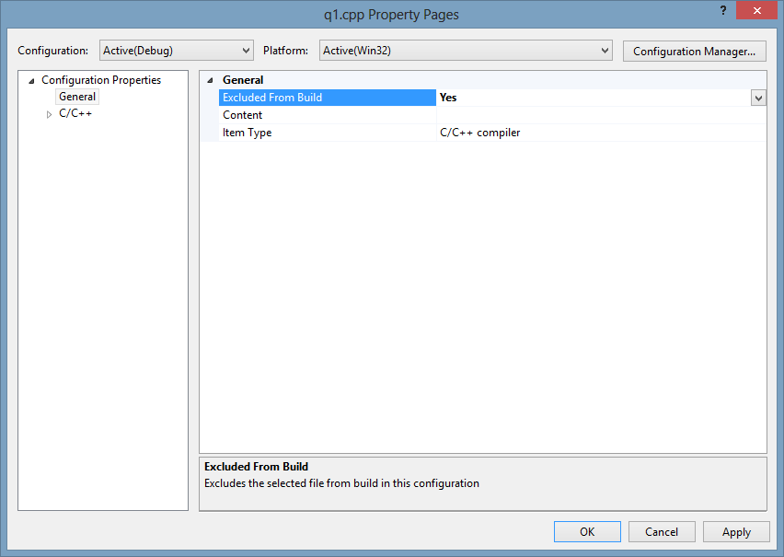

* 1. The file q1.cpp is now excluded from the Build / Compilation process. You can now run q2.cpp.

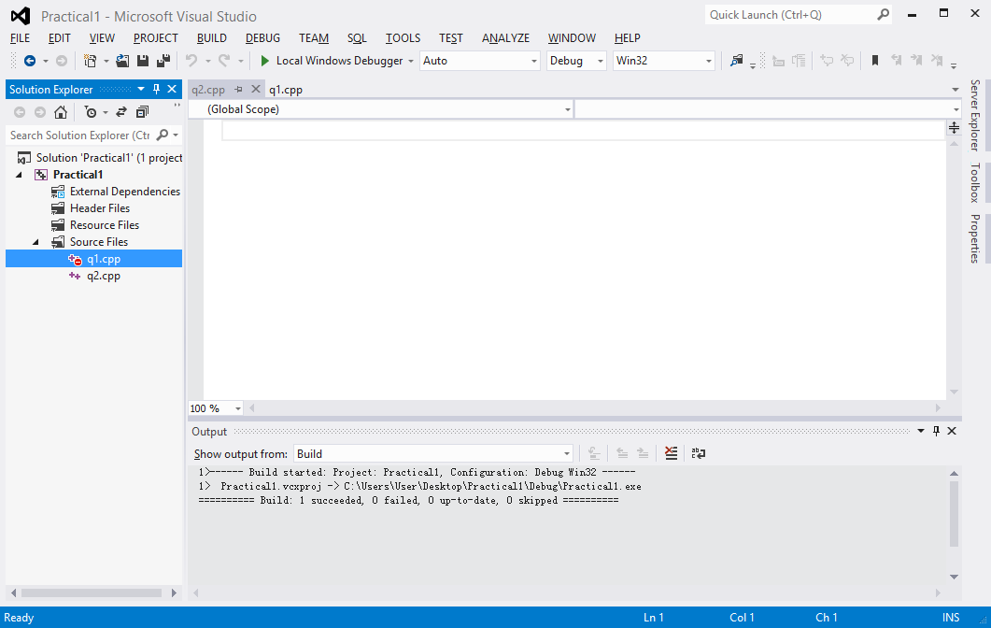

q1.cpp is excluded from Build